**VAISHAKH PILLAI**

website

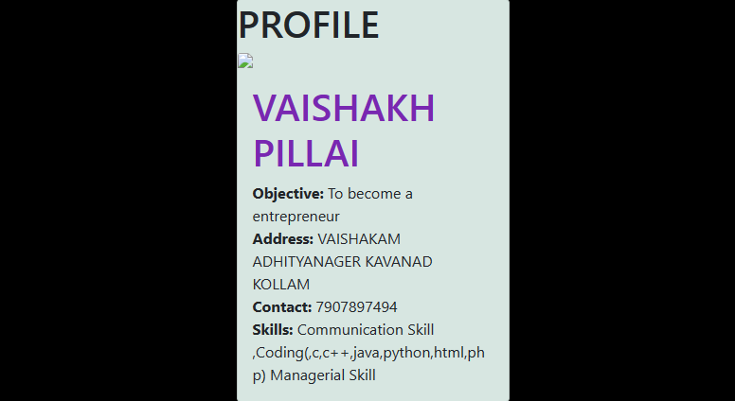

ADMIN

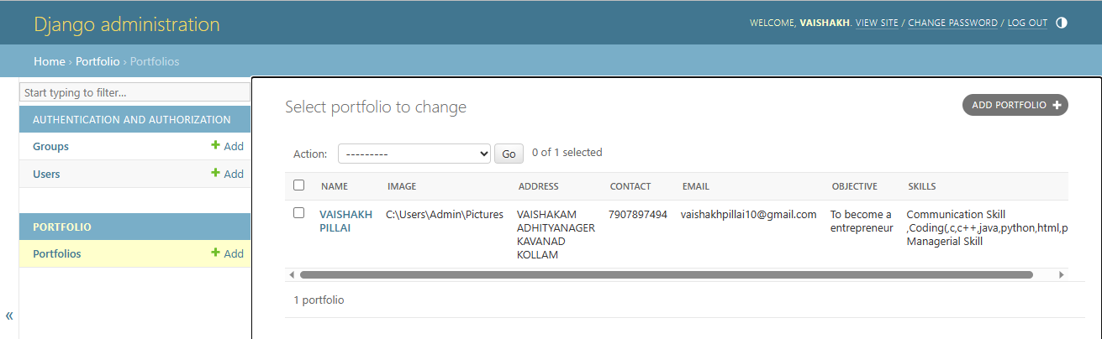

DATABASE

